

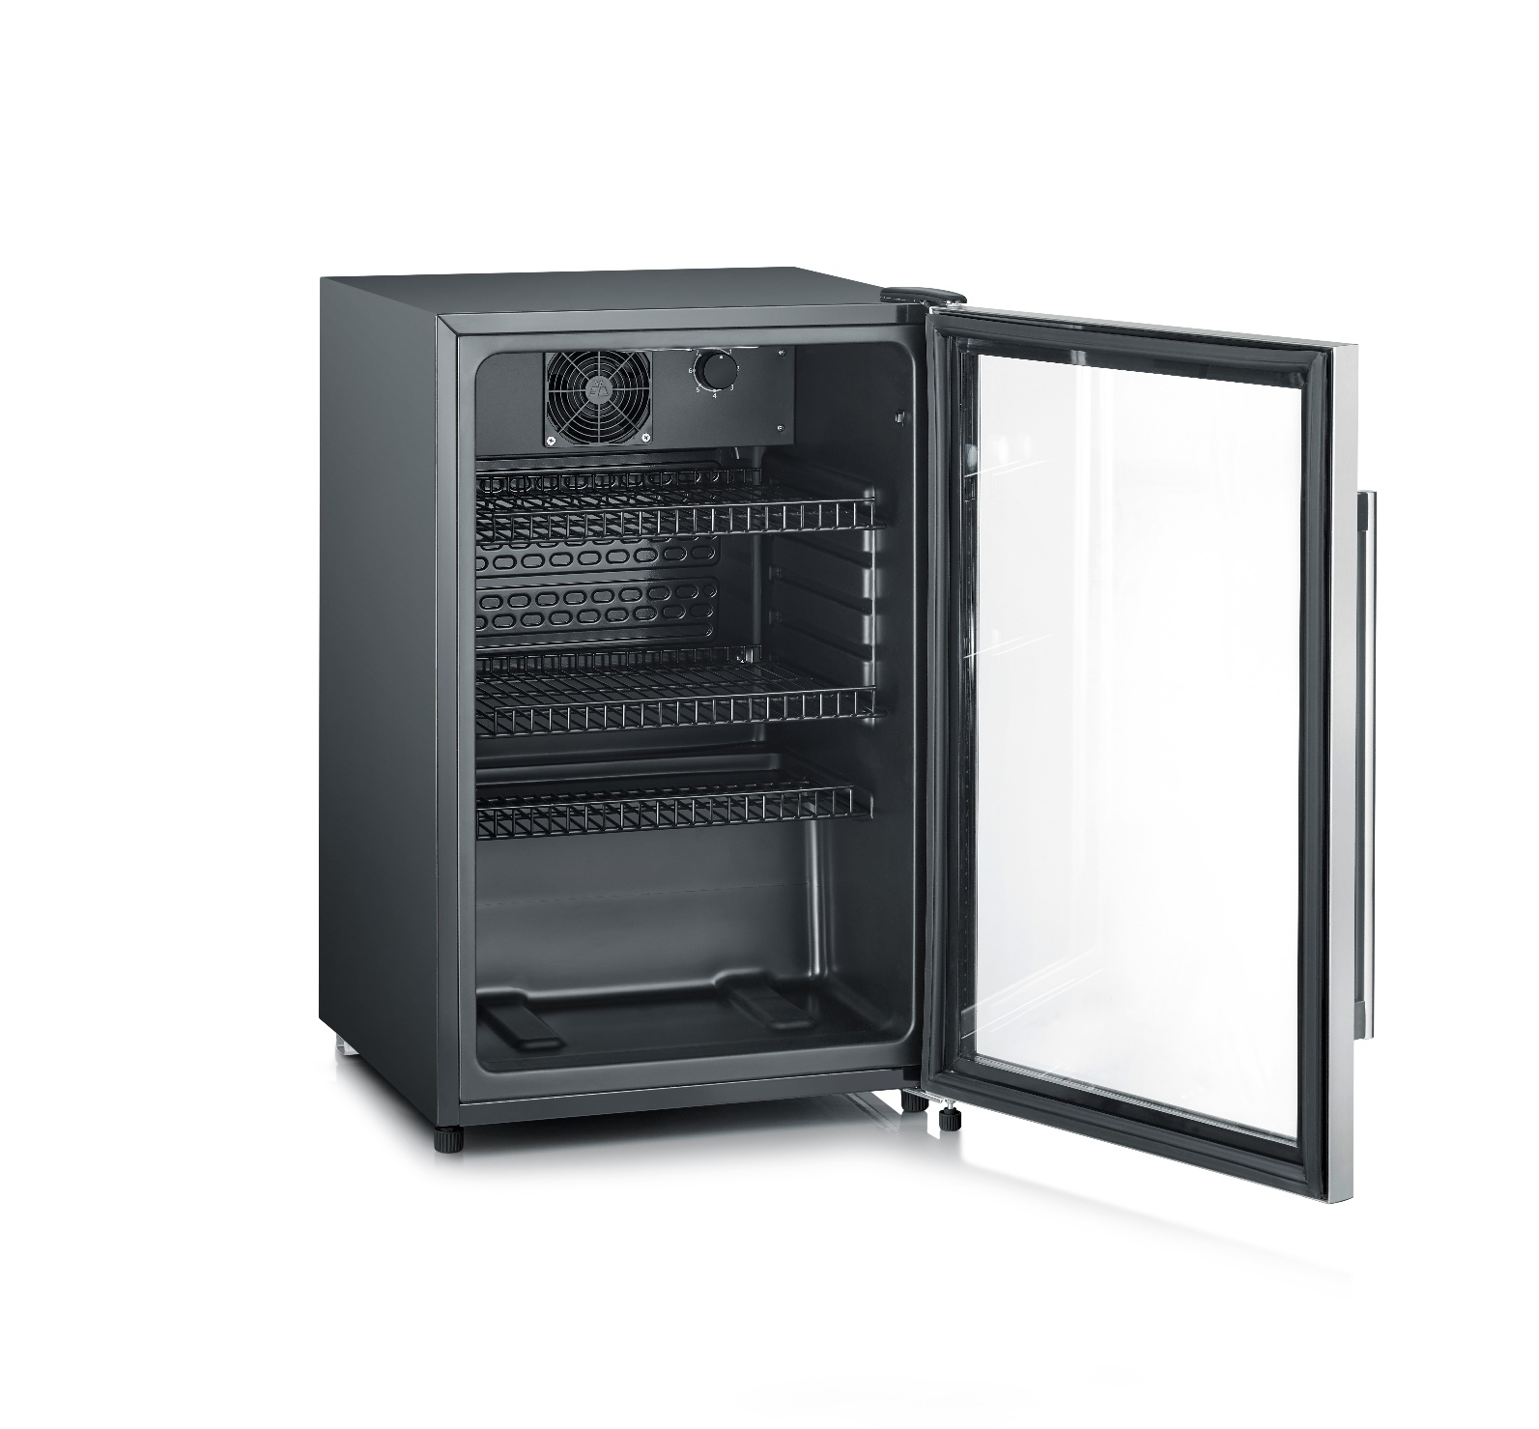

**Toasting, defrosting and reheating.**

Ein Bild, das Küchengerät, Haushaltsgerät enthält.

**USP at a glance:**

* **Variable width bread slot.**
* **Frozen bread button with pilot light.**
* **Reheat function with pilot light for rewarming without additional browning.**
* **Electronic browning control with temperature sensor.**

**AT 4321 - Toaster**

|  |  |
| --- | --- |
|  |  |
|  |  |
| **Even toasting**  Thanks to the variable width bread slot.    **All-rounder**  Taosting slices of bread and warming up  buns at the same time.  **Important data** | **Practical functions**  Frozen bread button, reheat function and  mid-cycle cancel button.    **Space-saver**  The detachable and foldable bun warmer  can be easily stored. |

**Product details**

|  |  |
| --- | --- |
| Wattage (in W) | 850 |
| Capacity (slices) | 2 |
| Colour | black |
| Cable length | 80 cm |
| Adjustable browning setting | Yes |
| Automatic switch-off in case of bread jam | Yes |
| Crumb tray | Yes |
| Measurements of the product (H x W x D in cm) | 16.5 x 15.5 x 29 |
| Measurements of the packaging (H x W x D in cm) | 19 x 18.5 x 30.5 |
| Net weight / Gross weight (in kg) | 1 / 1.3 |
| PU | 4 |
| GTIN-Code | 4008146042515 |
|  |  |